Name: K.Poorna chandu
Reg No: 192312585
Subject: ECA56 –5G / 6G Communication Systems

Experiment 6: 5G NR Frame Structure Analysis with Different Subcarrier Spacing
Aim:-
To analyze the 5G NR frame structure by studying the effect of different subcarrier spacings,
slot durations, and OFDM symbols using MATLAB.
Objective 1:
Program:
clc;
clear;
close all;
scs = [15 30 60 120 240]; % Subcarrier Spacing (kHz)
mu = 0:4; % Numerology Index
bar(scs)
grid on
set(gca,'XTick',1:5)
set(gca,'XTickLabel',mu)
xlabel('Numerology Index (\mu)')
ylabel('Subcarrier Spacing (kHz)')
title('5G NR Subcarrier Spacing for Different Numerologies')

Output:
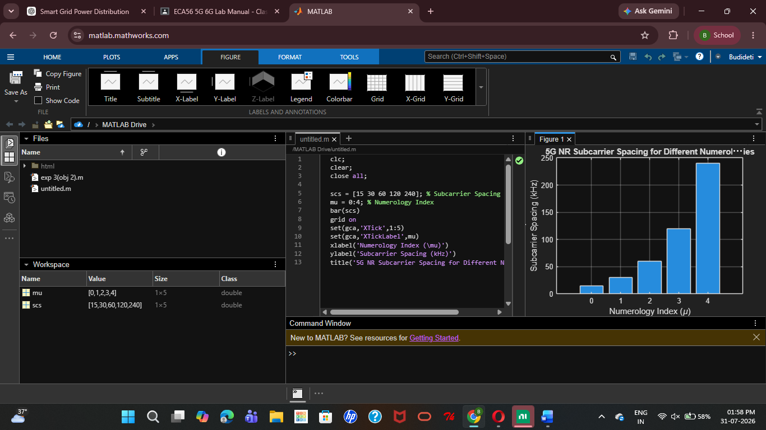

Objective 2:
Program:
clear;
close all;
scs = [15 30 60 120 240]; % Subcarrier Spacing (kHz)
slot = [1 0.5 0.25 0.125 0.0625]; % Slot Duration (ms)
plot(scs, slot, 'o-', 'LineWidth', 2)
grid on
xlabel('Subcarrier Spacing (kHz)')
ylabel('Slot Duration (ms)')
title('5G NR Slot Duration for Different Subcarrier Spacing')

Output:
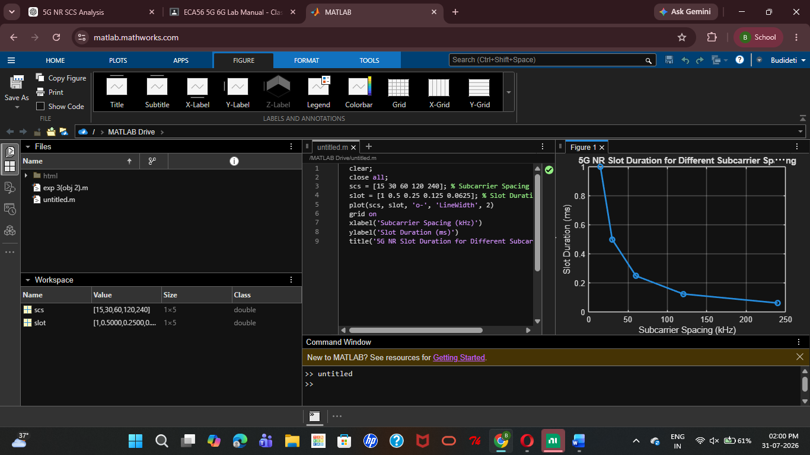
Objective 3:
MATLAB Code:
clc;
clear;
close all;
scs = [15 30 60 120 240]; % Subcarrier Spacing (kHz)
symbols = [14 14 14 14 14]; % OFDM Symbols per Slot
figure
bar(scs, symbols)
grid on
xlabel('Subcarrier Spacing (kHz)')
ylabel('Number of OFDM Symbols')
title('OFDM Symbols per Slot for Different Subcarrier Spacing')
ylim([0 16])

Output:
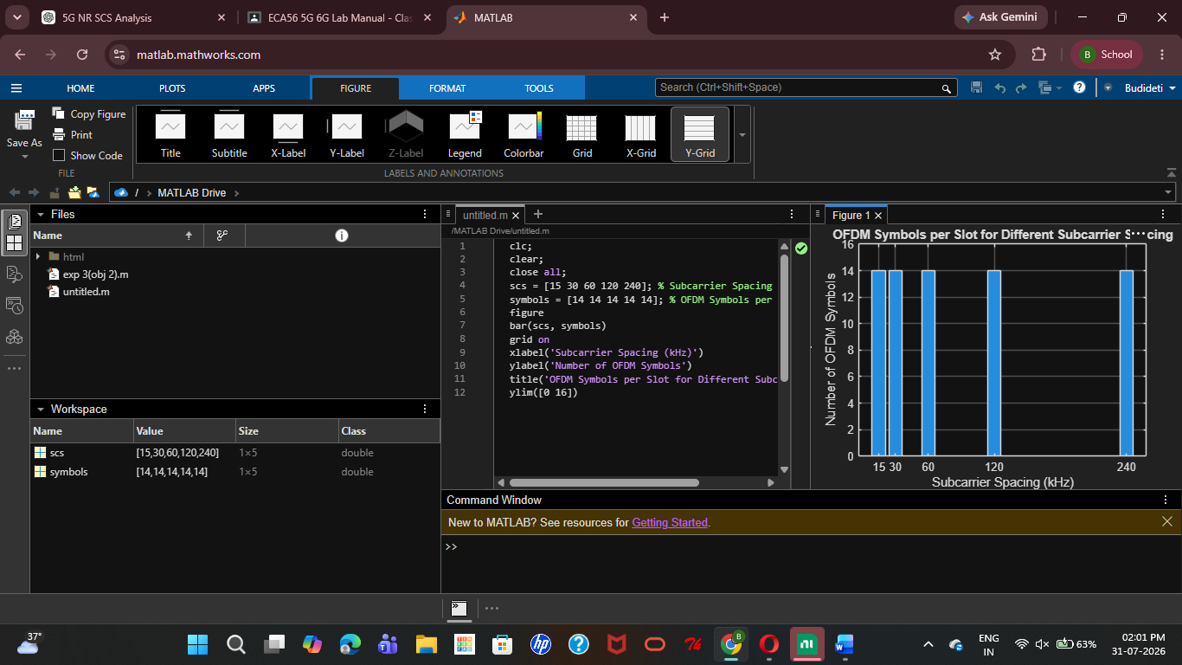

Result:
The simulation showed that increasing the Subcarrier Spacing (SCS) reduces the slot duration, enabling faster data transmission and lower latency. It was also confirmed that a 5G NR slot with a normal cyclic prefix always contains 14 OFDM symbols, irrespective of the SCS value.

